

DATABASE SYSTEM LAB

# Assignment 03



Submitted By:

Sana Shaheen CIIT/FA22-BCS-203/SWL(4-B)

Submitted To:

Sir Tahir Khalil

**DATE: May 18, 2024**

* **CREATE VIEW OF 3-TABLES:**

1. **Create Table1 and insert values:**

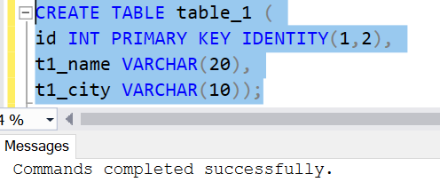

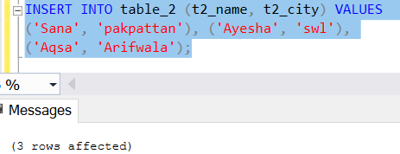

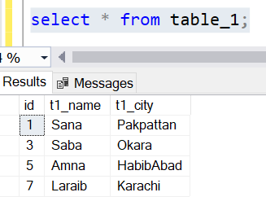

1. **Create Table2 and insert values:**

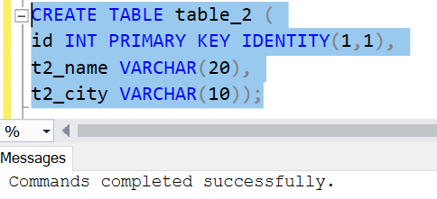



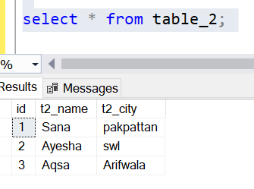

1. **Create Table3 and insert values:**

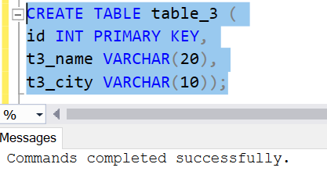

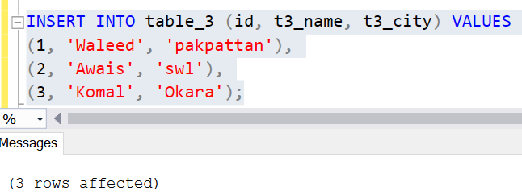

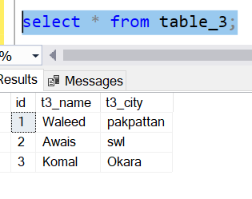

1. **Create INNER JOINView:**

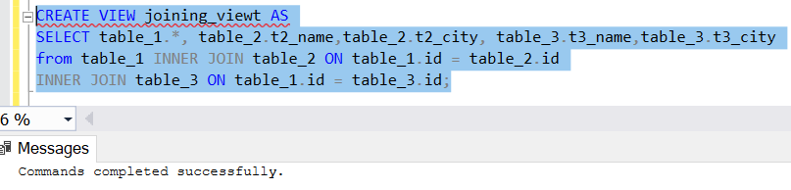

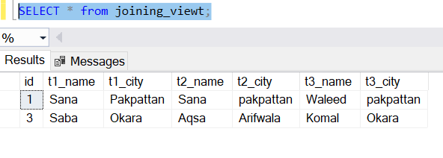

1. **Create LEFT JOIN View:**

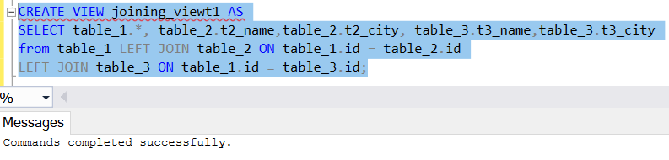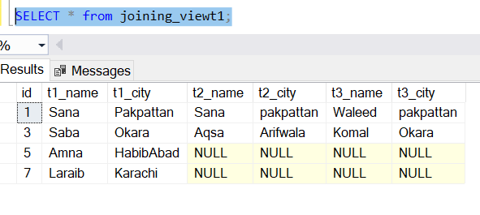

1. **Create RIGHT Join View:**

